TypeScript Exam Preparation
Link to Judge: https://alpha.judge.softuni.org/contests/typescript-exam-3-jan-2026/5379
Implement a modular, type-safe system using TypeScript, that demonstrates proficiency in Object-Oriented Programming (OOP) principles, Generics, and Decorators.

Skeleton code
You are provided with a complete project skeleton including a src folder and a tsconfig.json file.
- src/index.ts: This file serves as a testing playground. It contains a sample usage scenario (creating content, adding, searching).
- You may modify index.ts locally to debug and test your solution.
- Important: During the final evaluation, your solution will be tested against the original logic provided in the skeleton. Ensure your classes and methods maintain the expected signatures and behavior.
- Configuration: Do not modify tsconfig.json.

Implementation Requirements
Your task is to create the missing modules so that:
- the project compiles successfully
- index.ts executes without runtime errors
- all console outputs follow the expected behavior
You must implement four modules:
- models.ts
- hero-types.ts
- game-manager.ts
- decorators.ts

Module models.ts (10 Points)

(Foundational types)
This module defines the foundational types used across the system.
- HeroRole Enumeration
  - Create a String Enum named HeroRole with exactly the following string values:
    - Warrior = "WARRIOR"
    - Mage = "MAGE"
    - Archer = "ARCHER"
- WithId
  - Define a minimal interface used as a generic constraint for objects that contain a numeric ID:
    - must contain only id: number

- Hero Base Interface
  - Create an interface describing the common fields for all heroes. It must extend the WithId interface:
    - name: string
    - level: number
    - role: HeroRole
- Weapon Interface
  - Create an interface representing a weapon. It must extend the WithId interface:
    - name: string
    - damage: number

Module hero-types.ts (40 Points)

(OOP and Generics)
This module handles the content hierarchy and the core search logic.
Generic Class GuildStash<T>:
Implement a generic class to act as an inventory system
- Constraint: The generic type T must extend the WithId interface.
(Assume all items added to the stash have unique IDs)
- Internal State: Must maintain a private array of type T named records
(initialized as empty)
- Methods:
  - public add(item: T): void – Adds the item to the internal array
  - public take(id: number): T | undefined – Finds the item with the matching ID. If found, removes it from the array and returns it. If not found, returns undefined
  - public getAll(): T[] – Returns a new array containing a copy of all items currently in the stash
Abstract Class BaseHero:
- Must implement the Hero interface from models.ts
- Constructor: constructor(id: number, name: string, level: number, role: HeroRole)
- Must contain a public property weapons: Weapon[] initialized as an empty array
- Must define an abstract method calculateStamina(): number;
- Must define an abstract method attack(): number;
Classes (Warrior, Mage, Archer):
Important: The constructors of these subclasses should NOT accept role as a parameter. Instead, they must automatically pass the correct HeroRole to the super() call.
- Warrior
  - Constructor: constructor(id: number, name: string, level: number, public strength: number)
  - calculateStamina() formula: (level * 10) + (strength * 5)
  - attack() logic: Returns strength * 2
  - Role passed to super: HeroRole.Warrior
  - Decorator Application: Apply the @CriticalStrike decorator (from decorators.ts) to the attack method of this class

- Mage

  - Constructor: constructor(id: number, name: string, level: number, public mana: number)
  - calculateStamina() formula: (level * 5) + (mana * 2)
  - attack() logic: Returns mana * 2
  - Role passed to super: HeroRole.Mage

- Archer
  - Constructor: constructor(id: number, name: string, level: number, public agility: number)
  - calculateStamina() formula: (level * 8) + (agility * 4)
  - attack() logic: Returns agility * 2
  - Role passed to super: HeroRole.Archer

Module game-manager.ts (30 Points)

(Core Logic Integration)
Create the central GameManager class.
Collections:
- private heroes: BaseHero[] (initialized as empty)
- private stash: GuildStash<Weapon> (initialized as a new instance of GuildStash)

Methods:
- public addHero(hero: BaseHero): string
  - Adds the hero to the heroes array.
  - Returns exact string: "Hero "{name}" (ID: {id}) joined the guild."
- public addWeaponToStash(weapon: Weapon): string
  - Adds the weapon to the generic stash
  - Returns exact string: "Weapon "{name}" (ID: {id}) added to the guild stash."
- public equipWeapon(heroId: number, weaponId: number): string
  - First, finds the hero by heroId in the heroes array. If not found, returns exact string: "ERROR: Hero with ID {heroId} not found."
  - Next, attempts to take the weapon from the stash using this.stash.take(weaponId).
  - If the weapon is not found in the stash (returns undefined), returns exact string: "ERROR: Weapon with ID {weaponId} not found in the stash."
  - If both exist, adds the weapon to the hero's weapons array and returns exact string: "Weapon "{weapon.name}" equipped to hero "{hero.name}"."
- public listAllHeroes(): string[]
  - First line must be: "--- Guild Roster ---"
  - For each hero, add a line with the exact format:
"[{ROLE}] {name} (Level: {level}, {Specific Detail}) - Stamina: {stamina}"
Notes for formatting: * [{ROLE}] must print the exact enum string (e.g., [WARRIOR], [MAGE]).
  - Specific Detail requires type narrowing. You may use instanceof to access the unique properties:
    - Warrior: "Strength: {strength}"
    - Mage: "Mana: {mana}"
    - Archer: "Agility: {agility}"
  - Last line must be: "--------------------"
  - Returns the array of strings

Module decorators.ts (20 Points)

(Decorator)
@CriticalStrike Decorator
Implement a Method Decorator with the following signature:
export function CriticalStrike(target: object, propertyKey: string, descriptor: PropertyDescriptor)
Decorator behavior:
- Applied only to standard methods.
- It must intercept the method's execution by overriding descriptor.value
- It should call the original method to get the base damage value
- It must return the base damage multiplied by 1.5 (Critical Hit multiplier).Do NOT round the result (e.g., if the base is 75, the return value should be 112.5).
- If applied to a property that is not a function (i.e., if typeof descriptor.value !== 'function'), it must throw an Error with the exact message: "CriticalStrike can only be applied to methods"

Examples

Example 1: Heroes
const manager = new GameManager();
const warrior = new Warrior(1, "Arthur", 10, 50);
const mage = new Mage(2, "Gandalf", 20, 100);

console.log(manager.addHero(warrior));
console.log(manager.addHero(mage));

Output 1
Hero "Arthur" (ID: 1) joined the guild.
Hero "Gandalf" (ID: 2) joined the guild.

Example 2: Stash and Equipment
const manager = new GameManager();
const warrior = new Warrior(1, "Arthur", 10, 50);
const mage = new Mage(2, "Gandalf", 20, 100);

console.log(manager.addHero(warrior));
console.log(manager.addHero(mage));

const sword: Weapon = { id: 101, name: "Excalibur", damage: 120 };
const staff: Weapon = { id: 102, name: "Elder Staff", damage: 150 };

console.log(manager.addWeaponToStash(sword));
console.log(manager.addWeaponToStash(staff));

console.log(manager.equipWeapon(1, 101));
console.log(manager.equipWeapon(99, 102));
console.log(manager.equipWeapon(2, 999));

manager.listAllHeroes().forEach(line => console.log(line));

Output 2
Hero "Arthur" (ID: 1) joined the guild.
Hero "Gandalf" (ID: 2) joined the guild.
Weapon "Excalibur" (ID: 101) added to the guild stash.
Weapon "Elder Staff" (ID: 102) added to the guild stash.
Weapon "Excalibur" equipped to hero "Arthur".
ERROR: Hero with ID 99 not found.
ERROR: Weapon with ID 999 not found in the stash.
--- Guild Roster ---
[WARRIOR] Arthur (Level: 10, Strength: 50) - Stamina: 350
[MAGE] Gandalf (Level: 20, Mana: 100) - Stamina: 300
--------------------

Example 3: Decorator and Combat Test
const manager = new GameManager();
const warrior = new Warrior(3, "Conan", 15, 60);
const archer = new Archer(4, "Legolas", 15, 60);
const mage = new Mage(2, "Gandalf", 20, 100);

console.log(`Archer Attack: ${archer.attack()}`);

console.log(`Mage Attack: ${mage.attack()}`);

console.log(`Warrior Attack (Critical): ${warrior.attack()}`);

Output 3
Archer Attack: 120
Mage Attack: 200
Warrior Attack (Critical): 180

Example 4: Stamina Calculation
const manager = new GameManager();
const warrior = new Warrior(3, "Conan", 15, 60);
const archer = new Archer(4, "Legolas", 15, 60);
const mage = new Mage(2, "Gandalf", 20, 100);
console.log(`Warrior Stamina: ${warrior.calculateStamina()}`);

console.log(`Archer Stamina: ${archer.calculateStamina()}`);

console.log(`Mage Stamina: ${mage.calculateStamina()}`);

Output 4
Warrior Stamina: 450
Archer Stamina: 360
Mage Stamina: 300

- Submitting Your Solution
Place in a ZIP file your project folder. Include only src folder and tsconfig.json file.
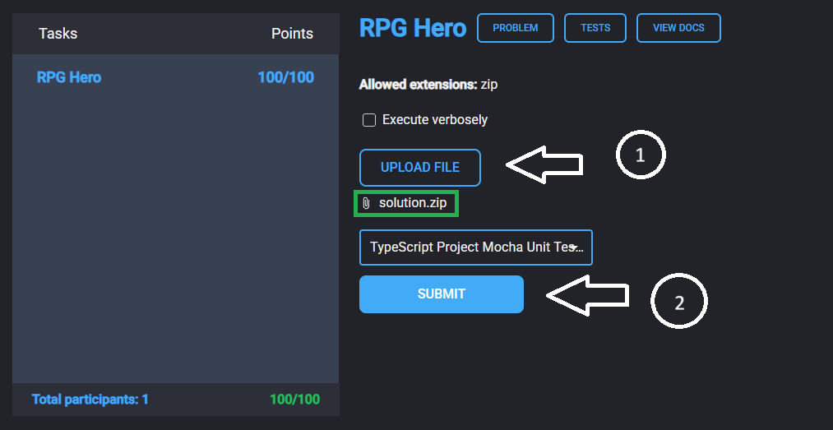
Submit your solution in Judge system.

